**Master Functional Document**

|  |  |
| --- | --- |
| **Application** | NGERP - Centra |
| **Service Bundle** | Master Management |
| **Service Request** | Role |

**Description :**

Role Is A Master Used To Control The User ‘s Access To The NGERP Centra Application.

**Workflow Process :**

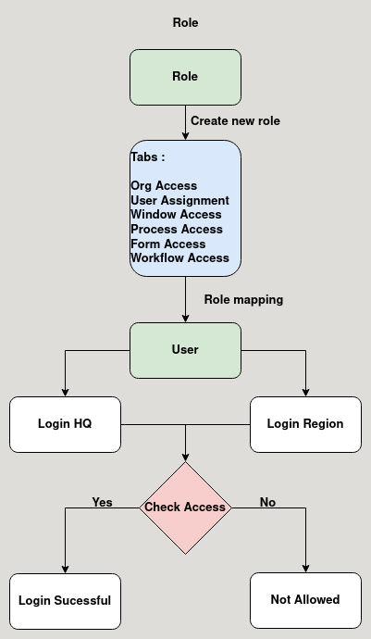

**Business Rules :**

* The Role Master screen is used to control the user access to the functionalities of the NGERP Application.
* There are Six Tabs In Role screen
  + - Org Access
    - User Assignment
    - Window Access
    - Process Access
    - Form Access
    - Workflow Access
* **Org Access:**

Org Access Tab is Used to give the user access to which organisation they are able to login.

* **User Assignment:**

This tab is used to assign user to the role.

* **Window Access:**

This tab is used to give the user access to the wiindows.

* **Process Access:**

This tab is used to give the user access to the process that they can run.

* **Form Access:**

This tab is used to give the user to process the form.

* Create a Role and give access to the Organisation on which the user want to login
* Create a user and map the role created.
* Now login to region, if the user has access to region then the login will be successful
* Else the organisation drop down does not show the region or HQ